

SUPERIOR UNIVERSITY LAHORE
GOLD CAMPUS

NAME: MUHAMMAD MOIZ RAZA
ROLL NO: SU92-BSAIM-F24-061
PROGRAM: ARTIFICIAL INTELLIGENCE
SEMESTER: 4th SEMESTER
SECTION: BSAI-4A
SUBJECT: PROGRAMMING OF AI (LAB)

Submission Title: LAB TASK 3
Submitted To: Sir Rasikh Ali

TITLE: Water Jug Problem Solver using Depth First Search (DFS)

OVERVIEW:
This lab task solves the water jug problem using depth first search in python. the program finds a way to measure a target amount of water using two jugs with different capacities by exploring all possible states step by step.

Technologies Used
python
depth first search algorithm
Working:
He program starts with both jugs empty and explores different actions like filling, emptying, or pouring water between the jugs. it keeps track of all visited states to avoid repeating steps. when the target amount is reached in either jug, it prints the complete sequence of steps to reach the solution.
Uses:
This task helps students understand search algorithms, recursion, and state-space problem solving. it is a common example in ai and computer science labs to demonstrate problem-solving strategies.
Screenshot:
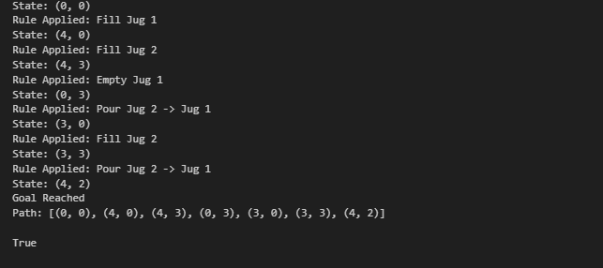

THE END

